Last updated: | July 2024

JOB DESCRIPTION

Post title: | Senior Administrative Officer
School/Department: | Student Administration and Academic Affairs
Faculty: | Student Experience Directorate (SED)
Career pathway: | Management, Specialist and Administrative | Level: | 3
*ERE category:
Posts responsible to: | Team Leader, Exams and Assessment (MSA 4)
Posts responsible for: | Administrative Officers (MSA 2B)  Administrative Assistants (MSA 2A)  Casual/Temporary staff
Post base: | Office-based (see job hazard analysis)

Job purpose
To coordinate the day-to-day operational support to students and academic staff in activities related to assessment (e.g. exam management; Boards of Examiners provision; External Examiner administration; Extensions/Special Considerations), awards and graduation.

To apply a detailed knowledge of systems and processes to support student administration and assessment activities.

To supervise/line manage the work of Administrative Officers and/or Administrative Assistants.

To establish and maintain effective working relationships with academic staff and colleagues within Student Administration and Academic Affairs and other Professional Services to ensure that agreed standard processes are implemented.

To be proactive in identifying improvements to services, processes and systems highlighted through the collection of feedback, evaluation and benchmarking.

Key accountabilities/primary responsibilities |  | % Time
 | Apply a detailed understanding of assessment policies, processes and systems to ensure that activities are delivered accurately, efficiently and by agreed deadlines, and identify potential improvements for further investigation. | 20%
 | Lead on delegated responsibilities within the team to deliver a set of the key activities and objectives. Build and maintain knowledge of systems and processes ensuring team integration, spread of knowledge and workload equivalency. | 20%
 | Work collaboratively with staff in Student Administration and Academic Affairs and other Professional Services to ensure that shared responsibilities for processes are discussed and equitable arrangements agreed. This will involve gaining a greater understanding of institutional developments, student-centred and customer service approaches | 15%
 | Oversee and coordinate own work and supervise the work of Administrative Officers and/or Administrative Assistants in the provision of an agreed level of service to students and academic staff. Plan and prioritise the team’s short and medium term work activities in response to agreed deadlines, monitoring individual progress and performance in line with this and providing regular updates to the Team Leader. | 15%
 | Ensure that the work of the team is completed accurately and that quality standards are maintained, escalating any issues to the Team Leader as appropriate. | 10%
 | Apply agreed customer-focused service standards to all students and stakeholders. Monitor progress on agreed service standards, reporting significant issues to the Team Leader. | 10%
 | Identify training and mentoring needs within supervised staff, providing guidance and coaching through on-the-job training to help them acquire skills and experience. Actively engage in the appraisal process to create an environment which values achievements, celebrates success, delivers balanced feedback and enables improvement. Report any significant issues to the Team Leader. | 5%
 | Be flexible and adaptable in the approach to work routines, undertaking any other duties as allocated by the line manager following consultation with the post holder. | 5%

Internal and external relationships
Internal
- Student Body
- Student Administration and Academic Affairs staff
- Office of the Academic Registrar
- Professional Services staff
- Faculty staff

External
- Students’ Union
- External Examiners
- Professional bodies

Special Requirements:
- Contribute towards broader initiatives to ensure and implement an excellent student experience. Participate in cross-functional activities such as induction events, Faculty examination events, international student registration, open days and student recruitment events, confirmation and clearing, graduation.
- Commitment to the integrity and confidentiality of all relevant data and processes
- Flexibility to take leave outside peak times in negotiation with the Senior Administrative Officer/Team Leader
- Demonstrate Southampton University behaviours (Embedding Collegiality – see Appendix 1below).

PERSON SPECIFICATION

Criteria | Essential | Desirable | How to be assessed
Qualifications, knowledge and experience | Either:  Possess A Level, HNC, NVQ3 or equivalent with relevant experience.  Or:  Broad work experience, acquired through a combination of job related training, considerable on the job experience, demonstrating development through progressively more demanding work roles. |  | Application  Application
Planning and organising | Capacity to organise data and schedule events, activities and resources and ensure they run smoothly.  Ability to plan and prioritise own short and medium term work activities within guidance offered by the Team Leader.  Ability to monitor timescales and resources and report to the Team leader issues which cannot be resolved within standard daily operation. |  | Application, interview and references
Problem solving and initiative | Ability to acquire and apply comprehensive knowledge of assessment processes, procedures and systems; use initiative and judgement to resolve daily problems within the team and guidance offered by the Team Leader.  Ability to acquire clear understanding of the quality and standards required for the delivery of Assessment in a customer focussed organisation. |  | Application, interview and references  Application and interview
Management and teamwork | Ability to contribute to team behaviours and interact effectively and sensitively with peers. Build effective social networks across SES and Professional Services; sustain productive workplace relationships for the long term.  Flexible and adaptable in approach to work routines, be able to adapt quickly to change; be open to working with different teams/individuals as the business demands. |  | Interview and references
Communicating and influencing | Effective partnership working and interpersonal skills  Capacity to speak to groups and individuals and explain processes clearly and concisely; and to write in a clear and factually/grammatically accurate way.  Ability to demonstrate adequate preparation for meetings so that time is used effectively.  Ability to demonstrate confidence and positive commitment to the University’s ways of working and explain these to all staff. |  | Application,  interview and references
Service Delivery | Evidence of a commitment to delivering services that add value from the perspective of the students and key staff.  Proactive approach to following the standards set for all staff and engagement in sharing best practice across the Team  Ability to maintain receptiveness to new ideas and approaches.  Ability to engage in appropriate training and staff development to ensure knowledge and skills are always up to date.  Capacity for patience and tolerance with large numbers of staff particularly when working under pressure. |  | Application, Interview and references
Information Technology Skills | Proficient database user; be fully conversant with Microsoft Office suite of products in particular working with large data sets.  Be proficient in using web based I.T solutions. | Proficient user of the Banner student record system. | Application and interview
Special requirements | Maintain the confidentiality of all data and materials at all times.  Flexibility to avoid taking leave during peak times for the team  Flexibility to undertake other duties as required by the Team Leader |  | Interview

Appendix 1. Embedding Collegiality

Collegiality represents one of the four core principles of the University; Collegiality, Quality, Internationalisation and Sustainability. Our Southampton Behaviours set out our expectations of all staff across the University to support the achievement of our strategy.

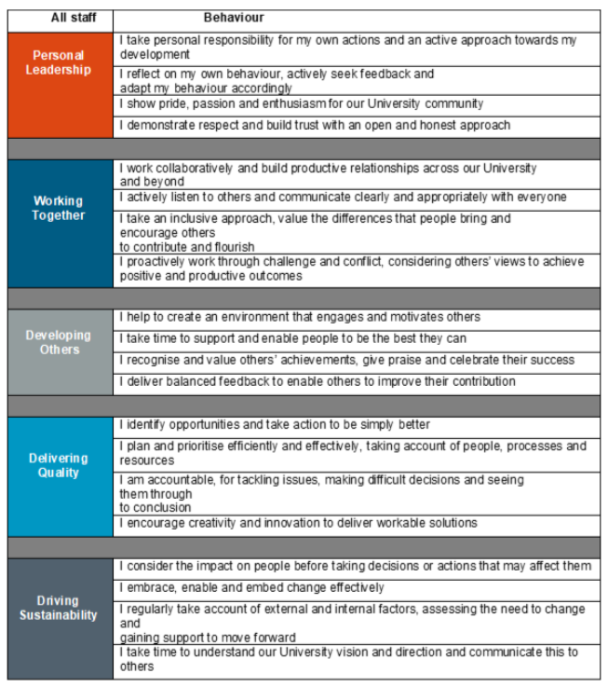

JOB HAZARD ANALYSIS

Is this an office-based post?
☒ Yes | If this post is an office-based job with routine office hazards (e.g.: use of VDU), no further information needs to be supplied. Do not complete the section below.
☐ No | If this post is not office-based or has some hazards other than routine office (e.g.: more than use of VDU) please complete the analysis below.  Hiring managers are asked to complete this section as accurately as possible to ensure the safety of the post-holder.

## - HR will send a full PEHQ to all applicants for this position. Please note, if full health clearance is required for a role, this will apply to all individuals, including existing members of staff.

ENVIRONMENTAL EXPOSURES | Occasionally  (<30% of time) | Frequently  (30-60% of time) | Constantly  (> 60% of time)
Outside work
Extremes of temperature (e.g.: fridge/ furnace)
## Potential for exposure to body fluids
## Noise (greater than 80 dba - 8 hrs twa)
## Exposure to hazardous substances (e.g.: solvents, liquids, dust, fumes, biohazards). Specify below:
Frequent hand washing
Ionising radiation
EQUIPMENT/TOOLS/MACHINES USED
## Food handling
## Driving university vehicles(e.g.: car/van/LGV/PCV)
## Use of latex gloves (prohibited unless specific clinical necessity)
## Vibrating tools (e.g.: strimmers, hammer drill, lawnmowers)
PHYSICAL ABILITIES
Load manual handling
Repetitive crouching/kneeling/stooping
Repetitive pulling/pushing
Repetitive lifting
Standing for prolonged periods
Repetitive climbing (i.e.: steps, stools, ladders, stairs)
Fine motor grips (e.g.: pipetting)
Gross motor grips
Repetitive reaching below shoulder height
Repetitive reaching at shoulder height
Repetitive reaching above shoulder height
PSYCHOSOCIAL ISSUES
Face to face contact with public
Lone working
## Shift work/night work/on call duties

